**Introduction**

Road geometries play a circumstantial role in designing for transportation. In autonomous vehicles, the current level of vehicle autonomy depends heavily on light sensors or radar sensor for detecting both objects and lane markings on the road. Based on this sensor information, vehicles are able to generate paths and trajectory approximations of where the vehicle should be going. In motion planning, a path is defined a set of possible ways a vehicle is allowed to go from Point A to Point B. While trajectory is defined as the profile needed to go through that path given different constraints. For example, many trajectories can lie inside of a given path as shown in Figure 1. Given constraints can be in the form of differential constraints from equations of motion, geometrical constraints or dynamic constraints from vehicle limits.

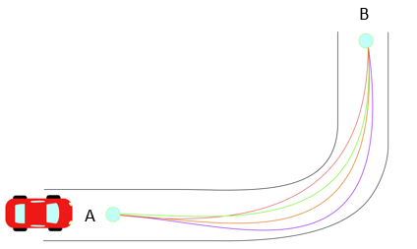

From literature, local trajectory generation techniques utilize different mathematical models. Such methods can be classified as roadmap-based planning [], sampling-based planning [], probabilistic methods [], and variational methods []. Most of these methods rely with the aid of vehicle sensors to generate their navigation map, for example discretizing areas of space from an image and classifying them as either navigation feasible or not. However, variational methods can be exploited outside of its dependence on image processing.

Variational methods arise from optimizing functionals with non-holonomic constraints (i.e. constraints on the velocity and acceleration). These methods yield polynomial solutions of high order that are treated as boundary value problems (BVP) during vehicle navigation. Along with variational methods, Clothoid functions (Cornu Spirals or Euler Spiral) are often studied in autonomous research because of their effectiveness to connect a straight line with a constant radius curve. Such that clothoids are used for road design and local trajectory generations. [][][]

These trajectory methods are then combined with optimization theory to be implemented into controllers for navigation purposes. In general, these trajectories focus on providing a continuous function (up to the third derivative) while being smooth (i.e. minimizing the jerk $\frac{d^{3}x}{dt^{3}}$). However, trajectories can also be generated from offline information that comes from different media such as GPS or geospatial data. Therefore, offline data provides a static calculation of the trajectories a vehicle should have regardless of any sensor error that vehicles could encounter during their trajectory calculations.

Thus, the objective of this research study is to develop a deterministic technique for identifying the centerline path of travel lanes using smooth, differentiable, parametric equations and geospatial road data. The rest of this paper is composed of the following sections: Trajectory Generation Background, Problem Solution, Recommendations and Conclusions.